Spring-Boot

Spring-Boot is an extension of spring framework, it is used to make spring-based application that is run independently. Spring Boot makes it easy to create stand alone, production – grade-based application that we can just run.

Key features-

* Auto-Configuration: Spring Boot automatically configures many aspects of your application based on the dependencies you include. This reduces the need for manual configuration.
* Standalone: Spring Boot applications can be run as standalone JAR files, which makes deployment and distribution easy.
* Production-Ready: Spring Boot includes built-in features for monitoring, health checks, and externalized configuration, making it suitable for production use out of the box.
* Microservices: It’s well-suited for building microservices and can be combined with Spring Cloud for more advanced distributed systems.
* Embedded Server
* The use of XML configuration is not needed.
* It comes with a large number of plug-ins.
* It boosts productivity and cuts down on development time.

Spring vs Spring-Boot

1 spring is framework of java EE for developing the web applications.

1 spring boot is a framework that is used for developing the rest API.

2 the key feature of spring is DI

2 the key feature of spring-boot is auto-configuration.

3 Spring doesn’t support the in memory database.

3 spring-boot supports the in memory database like h2.

4 In spring xml configuration is required.

4 In spring-boot there is a no need of xml.

5 It test the application in spring we need to configure the server.

5 Where spring-boot comes with embedded tomcat server.

Maven

Maven is a powerful project management tool that is based on POM (project object model). It is used for projects build, dependency and documentation.

Project Object Model (POM)

Maven is so useful thanks to the Project Object Model (POM), which is an XML file that has all the information regarding project and configuration details. The POM has the description of the project, details regarding the versioning, and configuration management of the project.

The XML file is located in the project home directory. When you execute a task, Maven searches for the POM in the current directory.

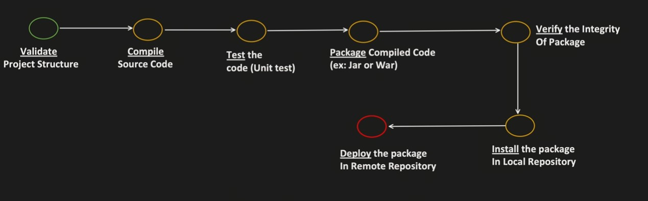

Build Lifecycle Phases

➜ validate : It is a phase that is about a check if the projects correct and all the necessary informations are available.

➜compile : Compiling the source code of the project.

➜test : Test the compiled source code with using a suitable unit testing framework.

➜package : Take the compiled source code and package it in its format(JAR, WAR, POM).

➜verify : Run and test the program to ensure the quality criteria are met.

➜install : Install the package into the local repository.

➜deploy : Project is done in the building environment. Remote and share it online.